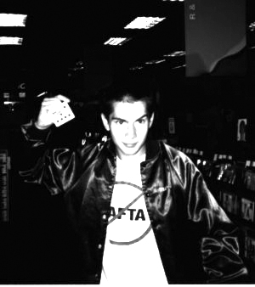

Throwing Cards Technique

1.1 Preface
1.2 Introduction
1.3 The Jay Grip
1.4 The Jay throwing technique
1.5 Illustrations for the Jay throwing technique
3.4 The Jay throwing technique with complete arm action
1.1 Preface

* The following passage (yes, the whole bloody lot) is quoted from Ricky Jay's book entitled "Cards as Weapons" (which is currently out of print and quite rare)
* Just as a summary, this page describes the basic way you ought to hold a card and provides a primer on throwing.
* When you finish mastering this page, you may want to look at other throwing techniques on the next page (see Throwing Card Styles & Stances)

1.2 Introduction

* The keys to the incredible Jay method of card-throwing are two: the Jay grip, and the ability to relax.

1.3 The Jay Grip

* First we must assume that the card can express four directions. The four corners of the card will now be designated as Northeast, Southeast, Northwest and Southwest.
* Place the Northeast corner of the card into the fleshy part of the right index finger tip.
* The right second finger is placed under the card about one inch down from the index finger along the Eastern edge of the card. The right thumb is placed over the card in exactly the same position. The thumb and second finger has the card pinched between them. If the cards were not present the position of these fingers would be identical to that used in passing the tiniest piece of cigarette to a close friend.
* The third and fourth fingers are kept out of the way: this is most easily done by curling them inward to touch the palm. The Eastern edge of the card makes contact with the hand only where it is grasped by the first two fingers and thumb: the card does not touch the palm of the hand at this time. This is very important. Later, when the wrist is turned inward, the Southeast corner of the card will hit the base of the palm, but it does not do so yet. You are now ready to learn the Jay throwing technique.

1.4 The Jay throwing technique

* The basic spinning motion will be discussed first; the arm action for longer throws will be described later.
* 1. Sit comfortably in a chair (not an armchair). Your left hand, which holds the deck, rests in your lap.
* 2. Grasp a card in your right hand in the Jay grip. The right arm rests loosely against the right side of the body.
* 3. Bend the arm at the elbow so that the hand is now about six inches above your knee and parallel to the floor.
* 4. Bend your wrist towards your body until the Southeast corner of the card touches your hand at the base of the palm.
* 5. The wrist now straightens, returning to the original position, as the fingers release the card. The card glides out over the second finger, spins forward for a few inches (or feet), and falls to the floor. The motion of the wrist is the same as that employed in dismissing an incompetent valet.
* After you get the feel of this motion you are ready to add arm action; this will provide greater stability and distance.

1.5 Illustrations for the Jay throwing technique

* The following pictures were scanned from Ricky Jay's book Cards as Weapons.

1)
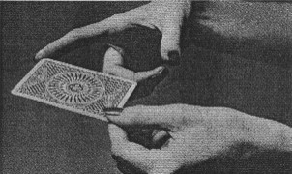
2)
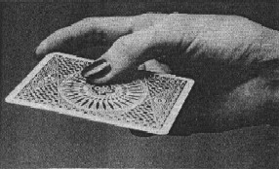
3)
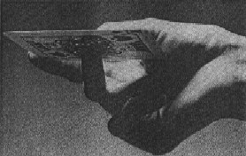
4)
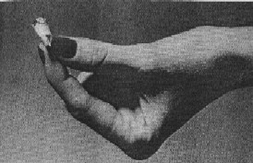
5)
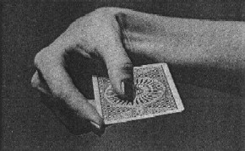
6)
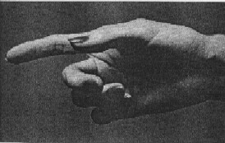

3.4 The Jay throwing technique with complete arm action

* The entire throwing action is similar to that of scaling a Frisbee or saucer and the motion of the arm bending back at the elbow is like the swing of a pendulum. This back-and-forth action may be repeated a few times before the release of the card as a sort of warm-up exercise; this is similar to practice-stroking before the shot in a game of billiards.
* 1. Resume the relaxed position in the chair. The chair will be familiar with you by this time and it too will be relaxed.
* 2. Hold the card in the Jay grip and straighten out the arm, keeping it parallel to the floor.
* 3. Keeping the arm in the same plane, bend the arm in at the elbow, back toward your body, at an angle of 9O~.
* 4. The wrist continues to move back but the arm remains stationary until the card touches the base of the palm exactly as in the spinning exercise.
* 5. The wrist and arm swing forward to the original straight position and at this point the card is released.
* 6. The follow-through: as the card is released the wrist goes further to the right of the extended straight arm and the fingers open slightly in a flicking motion.

Throwing Card Styles and Stances

normal techniques
2.1 Preface
2.2 The Flick
2.3 The Butterfly Swirl
2.4 The Sea-Urchin Spin
2.5 The Dolphin Dart

special techniques
3.1 The Children's Cudgel
3.2 An Illustration of the Children's Cudgel
3.3 The Round-Up
3.5 The Lethal Four-Card Fist
3.5 An Illustration of the Four-Card Fist

2.1 Preface

* As before, the following passage list is quoted from Ricky Jay's Cards as Weapons
* This list describes different ways one can throw cards in self-defense. The first four are classic long-distance methods (listed in increasing difficulty), while the other 3 are only for use in specialized situatations.
* When you finish mastering this page, you may want to look at a description of critical nerve sites & pressure points on an anatomy map (see Critical Nerve Centers)

2.2 The Flick

This throw is used for its distracting effect and it is not meant to cause harm or do bodily injury.
*
Hold and throw the card as explained in the chapter on technique, releasing the card softly as you did in the practice throw. Should this card hit bare flesh it will cause only minor annoyance but will serve as a warning and let the enemy know you're out there.

2.3 The Butterfly Swirl

*This has a bit more bite than the preceding throw. The grip is the same but the card should be held with a lighter and gentler touch. The index finger cocks against the Northeast corner of the card and creates enough resistance to create additional spin as the card is released. The card will now travel with more revolutions per second (rps) and this produces greater impact as a surface is struck. In the pain-tolerance tests conducted at Duke University many people described the reaction to the Butterfly Swirl with the word aculeus which is defined as the bite of an insect, hence the slogan "Float like a butterfly, sting like a bee."

2.4 The Sea-Urchin Spin

The conventional grip is used but the card must be thrown with added force which is provided by the arm and shoulder. The arm should be raised to an angle of almost 45° as it crosses in front of the body prior to release. When the hand releases the card there should be a noticeable downward snap. The hand and body must move together to make this throw effective. When this technique is mastered this throw can produce a stinging, pinching sensation, even against the Levi-clad posterior of an adversary, and blood may be drawn if bare flesh is struck. The pain inflicted by this throw is likened to stepping on the articulated spines of the edible sea-urchin echinus esculentus found in the sub-littoral zones of the British Isles.
*

This throw is critical in the mastery of self-defense. Though not lethal, it can be very damaging around the eyes and throat, bothersome to the point of true annoyance at the mouth and ears.

2.5 The Dolphin Dart

The power of this throw has its analogue in the great driving force of the tursiops truncatus or common bottlenosed dolphin. The dolphin rams its opponent, the shark, at speeds in excess of thirty knots causing great internal injury to that predator. Using this technique, a card may be thrown with great speed and have a comparable effect on one's enemies.

For this throw the hand is almost straight overhead and the card held firmly in the standard grip. The right foot points straight ahead and the arm straightens in a forward direction snapping the card out at neck level in the same vertical plane as the extended foot. The card's flight should be such that a whirring sound is heard. This shot is very difficult and early attempts may cause the card to flutter to the ground at the thrower's feet. The release and snap must be timed correctly and the arm must move smoothly, though powerfully, at all times.
*
The Dolphin Dart is currently gaining popularity in this country, but for years was the favorite of Japan's Yakuza hit-men. It is precise and reliable and should be used only in life-and-death struggles. In addition to the areas mentioned in the Sea-Urchin Spin, the Dolphin Dart is also effective at the temples, heart, and kneecaps, and can paralyze a victim if it hits any vital pressure points at close range.

3.1 The Children's Cudgel

* The entire deck is used to jab and strike an opponent at close range in this exercise. With the right hand assume the familiar hitchhiker's posture, thumb extended and fingers curled in a loose fist. Place the deck into the hand so the fingers curl around the east side of the deck. Move the thumb down to the top of the deck and turn the wrist to the right so you are now looking at the back of your hand; if your hand is large it may be impossible to see the cards from this position. This is a distinct advantage and gives you the additional advantage of the element of surprise. The cards should be gripped tightly and the blow may be delivered by shooting the arm stiffly to the right for a distance of no more -than five or six inches It is best to direct the cards against the knuckles, solar plexus, groin or head of an opponent This technique finds its genesis in a sadistic children's game called "Knucks."

3.2 An Illustration of the Children's Cudgel

* The following picture was scanned from Ricky Jay's book Cards as Weapons.

1 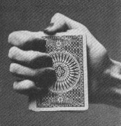

3.3 The Round-Up

* This full-deck technique both stings and confuses the enemy. Hold the deck in dealing position in the left hand, which should be re1axed. When you sense an enemy attack, extend your right hand in the familiar handshake mode and surreptitiously lower the left hand. Quickly bring the left hand forward hurling the entire deck at the face of your assailant, thus befuddling him.

3.4 The Lethal Four-Card Fist

*

This is the author's own defense against multiple adversaries. It was developed in New York but has a distinctly Oriental flavor and may be used in most geographical areas.
*

Place a card between the first and second fingers of the right hand, using the Thurston Grip explained in Chapter Four. Next, place a card between the second and third fingers and then one between the third and fourth fingers; finally a card is placed on top of the index finger and secured by the gentle pressure of the thumb pressing down against the top of the card. All the cards are held in the same relative position; looking down from above, one should see only the top card and not the three beneath it.
* To fire, bring the right arm across the body and then extend it forward, releasing all four cards at once. The cards will spread slightly on release; the top card goes to the left, the bottom card to the right The two center cards will travel the furthest. With practice, one can strike four individuals simultaneously. This technique is particularly useful in gang warfare and most effective when the user can throw with both hands. A skilled helper is required to load cards between the empty fingers of the person throwing. In this way two men can hold off a small army of foes.

3.5 An Illustration of the Four-Card Fist
*The following picture was scanned from Ricky Jay's book Cards as Weapons.
